Spring DataFlow YARN Deployer

Spring Cloud DataFlow可以deploy到YARN模式下，

*bin/dataflow-server-yarn*

*hdfs dfs -put spring-cloud-deployer-yarn-tasklauncherappmaster-1.2.2.RELEASE.jar /dataflow/apps/task/*

*bin/dataflow-shell*

执行如下：

*dataflow:>app register --name timestamp --type task --uri maven://org.springframework.cloud.task.app:timestamp-task:1.3.0.RELEASE*

*Successfully registered application 'task:timestamp'*

*dataflow:>app list*

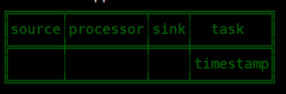

*dataflow:>task create --name printTimeStamp --definition "timestamp"*

*Created new task 'printTimeStamp'*

*dataflow:>task list*

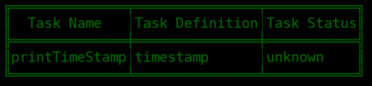

*dataflow:>task launch printTimeStamp*

*Launched task 'printTimeStamp'*

*dataflow:>task execution list*

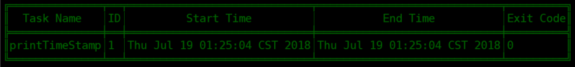

执行后，打开yarn页面：

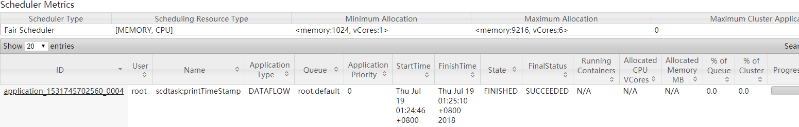

执行成功。打开yarn container日志

1. yarn appMaster日志

*vim Appmaster.stdout*

*Starting TaskAppmasterApplication v1.2.2.RELEASE on cmhhost2.novalocal with PID 5887 (/hadoop/yarn/local/usercache/root/appcache/application_1531745702560_0004/filecache/10/spring-cloud-deployer-yarn-tasklauncherappmaster-1.2.2.RELEASE.jar started by yarn in /hadoop/yarn/local/usercache/root/appcache/application_1531745702560_0004/container_1531745702560_0004_01_000001)*

*o.s.c.d.s.y.tasklauncher.TaskAppmaster : Using command list for task container: $JAVA_HOME/bin/java,,-Dserver.port=0,-Dspring.jmx.enabled=false,-Dspring.config.location=servers.yml,-jar,timestamp-task-1.3.0.RELEASE.jar,--spring.datasource.driverClassName='org.h2.Driver',--spring.datasource.username='sa',--spring.cloud.task.name='printTimeStamp',--spring.datasource.url='jdbc:h2:tcp://localhost:19092/mem:dataflow','--spring.cloud.task.executionid=1',1><LOG_DIR>/Container.stdout,2><LOG_DIR>/Container.stderr*

1. 打开container日志

*Executed SQL script from class path resource [org/springframework/cloud/task/schema-h2.sql]*

*TimestampTaskConfiguration$TimestampTask : 2018-07-19 01:25:04.643*

执行成功

https://docs.spring.io/spring-cloud-dataflow/docs/current/reference/htmlsingle/#getting-started

https://github.com/spring-cloud/spring-cloud-deployer-yarn

http://docs.spring.io/spring-cloud-dataflow-server-yarn/docs/current-SNAPSHOT/reference/htmlsingle/#yarn-deploying-on-yarn